# Summer Children’s Programs

# Greenville Public Library – **618-664-3115**

# 414 West Main Street

Saturday Story Times

Starts at 10:00 a.m.

**June 9 – “Jungle Animals”**

**July 7 – “Arctic Animals”**

**August 4 – “Forest Animals”**

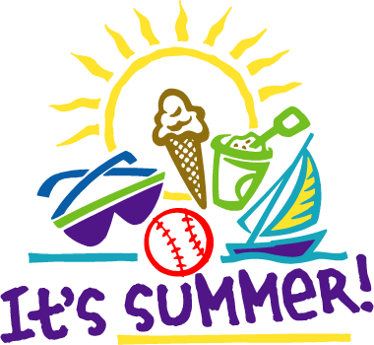

**Summer Program Dates**

**June 1 – “Ice Cream For Books” Begins (Start your summer reading log!)**

**July 5 – 2:00 p.m. Shawn Cox, Music Man  
July 11 – 2:00 p.m. Dr. Lynette Hemker, Veterinarian  
July 18 – 2:00 p.m. Dr. Sandra Schmidt, Storyteller**

**July 25– 2:00 p.m. Princess Lugge Concert**

**Aug 1 – “Ice Cream For Books” End**

# Summer Children’s Programs

# Greenville Public Library – **618-664-3115**

# 414 West Main Street

Saturday Story Times

Starts at 10:00 a.m.

**June 9 – “Jungle Animals”**

**July 7 – “Arctic Animals”**

**August 4 – “Forest Animals”**



Summer Program Dates

**June 1 -“Ice Cream For Books” Begins**

**(Start your summer reading log!)**

**July 5 – 2:00 p.m. Shawn Cox, Music Man**

**July 11– 2:00 p.m. Dr. Lynette Hempker, Veterinarian**

**July 18 – 2:00 p.m. Dr. Sandra Schmidt,**

**Storyteller**

**July 25 – 2:00 p.m. Princess Lugge Concert**

**Aug. 1 – “Ice Cream For Books” Ends**